IOT BASED WATER LEVEL AND QUALITY MONITORING SYSTEM

ODERINDE TIMILEYIN OLUWASEUN
20EG01015

DEPARTMENT OF COMPUTER ENGINEERING
FACULTY OF ENGINEERING
AJAYI CROWTHER UNIVERSITY, OYO

IN PARTIAL FUFILMENT OF THE REQUIREMENT FOR THE
AWARD OF
THE DEGREE OF BACHELOR OF ENGINEERING (B. ENG.), COMPUTER ENGINEERING

JUNE, 2025

CERTIFICATION

The project work with the title “IOT BASED WATER QUALITY AND MONITORING SYSTEM” submitted by ODERINDE,Timileyin Oluwaseun, with matric number 20EG01015 was carried out under the supervision at AJAYI CROWTER UNIVERSITY, OYO.

Engr. Dr.S. Adigun
Signature & Date

Signature & Date

Engr. Dr. M.O. Oyediran

Prof. S.O Jekayinfa

Signature & Date

DEDICATION
I dedicate this paper to the Almighty God, the most merciful, the most beneficent, who is my provider and the keeper of my life. I also dedicate this work to my beloved parents.

ACKNOWLEDGEMENT
I would like to express my heartfelt gratitude to everyone who contributed to the successful completion of this project. This achievement would not have been possible without the support, guidance, and encouragement of several individuals and institutions.
First and foremost, I am deeply thankful to my supervisor, Engr. Dr.S. O Adigunfor his invaluable guidance, insightful feedback, and continuous encouragement throughout the course of this project. His expertise and constructive suggestions played a crucial role in shaping the direction and outcome of my work.
I am also grateful to Ajayi Crowther Universityand the Department of Computer Engineering for providing the necessary resources and facilities that enabled the practical execution of this project. Special thanks to the lab technicians and support staff for their assistance and cooperation.
I sincerely appreciate the support and motivation I received from my colleagues and friends. Their helpful discussions, encouragement, and positive spirit were a great source of strength during the more challenging phases of this journey.
Finally, I extend my deepest gratitude to my parents and friends for their unwavering support, love, and belief in me. Their constant encouragement and understanding have been instrumental in my academic growth and personal development.

ABSTRACT
The increasing challenges of water scarcity, pollution, and ineffective management call for the adoption of advanced monitoring systems to ensure safe and sustainable water use. This project presents the design and implementation of an IoT based water level and quality monitoring system aimed at addressing the limitations of traditional, manual methods. The system employs a network of sensors,turbidity sensors, TDS sensors and ultrasonic sensor interfaced with an Esp32 microcontroller to measure critical water parameters in real-time. Sensor data is transmitted wirelessly to the blynk cloud platform, enabling remote access, real-time alerts, and automated control of water pumps based on water level thresholds.
The system provides a cost-effective, scalable and efficient solution for continuous water quality assessment and level monitoring, sustainable for both urban and rural environments. By enabling timely detection of contamination and abnormal water levels, it helps in prevention health risks, environmental hazards, and water related disasters. The integration of cloud-based data visualization, automated alerts, and user-friendly mobile control demonstrates the potential of IoT in transforming water management practices and contributing to public health and environmental sustainability.

TITLE PAGE
TITLEPAGE i
CERTIFICATION ii
DEDICATION iii
ACKNOWLEDGEMENT iv
ABSTRACT v
TABLE OF CONTENTS vi
LIST OF FIGURES ix
LIST OF TABLES x
CHAPTER ONE 1
INTRODUCTION 1
1.1.Background of the study 1
1.2. Statement of problem 2
1.3. Aim and objectives 3
1.3.1Aim of the study 3
1.3.2 Objective of the study 3
1.4.Significance of the study 4
1.5. Scope of the study 5
1.6.Methodology Overview 5
1.7. Definition of key terms 6

1.8.Organization of subsequent chapters 7
CHAPTER TWO 8
LITERATURE REVIEW 8
2.1 Introduction 8
2.2.1Historical background of IoT based water level and quality monitoring system 9
2.2.2 Early methods of water monitoring 9
2.2.3The Evolution of water quality measurement 9
2.3Related works 12
CHAPTER 3 16
METHODOLOGY 16
3.0Introduction 16
3.1System Requirement 17
3.1.1. Functional requirement 17
3.1.2. Non-functional requirement 18
3.2. System Design 19
3.2.1.Architectural Design 19
3.2.2 Hardware components 20
3.2.3.Software components 23
3.2.4 System Workflow………………………………………………………………………………………………….......24
3.3 Data Transmission 25
3.31. Use of Wi-Fi/GSM for Wireless Communication……………………………………………………25
3.4Developmental process 26
3.5.Ethical considerations 27
3.6.Testing and calibration 28
3.6.1.Testing Process….……….………………………………………………………………...28

3.6.2 System Testing and validations……………………………………………………...........29

3.7Performance Evaluation 32
CHAPTER FOUR 44
RESULT AND DISCUSSION 44
4.0 INTRODUCTION 44
4.1. CONSTRUCTION 45
4.1.1 Phased Construction Strategy 45
4.1.2 Quality Control Measures 47
4.2 HARDWARE CONSTRUCTION AND ASSEMBLY 48
4.2.2. Sensor and mounting 49
4.3 SOFTWARE IMPLEMENTATION AND PROGRAMMING………………………….50

4.31. Calibration process…………………………………………………………………...50

4.4 Casting and Boxing……………………………………………………………………….51

4.5 Performance and evaluation………………………………………………………………52

4.5.1 Measurement Accuracy Assessment…………………………………………………..52

4.5.2 Response Time Breakdown…………………………………………………………...53

4.5.3 Future Performance evaluation………………………………………………………...53

4.6 PROBLEM ENCOUNTERED……………………………………………………………54

CHAPTER 5 56
CONCLUSION AND RECOMMENDATION 56
5.1 Conclusion 57
5.2 Recommendations of future work………………………………………………………58

Refrences 62

LIST OF FIGURES
Figure 1.0: IMAGE OF PREVIOUS IOT BASED WATER LEVEL AND MONITORING SYSTEM…………………………………………………………………………………….…..19
Figure 2.0: MICROCONTROLLER…………………………………………………………….27
Figure 3.0: ULTRASONIC SENSOR....................................................................................…...28
Figure 3.1: TDS SENSOR ……………………………………………………………………...29
Figure 3.2: TURBIDITY SENSOR……………………………………………………………..30
Figure 3.3: SYSTEM DESIGN………………………………….………………………………32
Figure 3.4: CIRCUIT DIAGRAM……………………………….………………………………33
Figure3.5: FLOW CHART OF IOT BASED WATER LEVEL AND QUALITY MONITORINGSYSTEM………………………………………………………………………………………...39
Figure 4.0: FINAL CASTING OF PROJECT…………………….…………………………….52
Figure 4.1: INSIDE THE PROJECT CASTING………………….…………………………….53
Figure 4.2: INSIDE THE PROJECT CASTING………………….…………………………….53

CHAPTER ONE
INTRODUCTION
1.1 Background of the Study
The need for efficient water quality and level monitoring has become increasingly significant due to growing concerns over water scarcity, pollution, and the demand for sustainable water management. Traditionally, water quality and level assessments were done manually through periodic sampling and laboratory testing. While these methods provided valuable data, they were slow and could not keep up with real-time monitoring demands. The emergence of the Internet of Things (IoT) has revolutionized water monitoring by enabling continuous, real-time data collection, making it possible to track critical water parameters remotely and efficiently. IoT has transitioned water monitoring systems from manual processes to interconnected, automated solutions that offer real-time insights into water status, thus improving decision-making and response times (Shah, 2020). Early water monitoring systems were often isolated and had limited capabilities, relying on basic sensors and manual observation. With the advent of IoT, these systems became more sophisticated, enabling real-time data transmission from water sources to cloud platforms where the data can be analyzed and monitored remotely. This shift allowed for greater flexibility, enabling stakeholders to access information anytime, anywhere, through smartphones or computers (Rashid et al., 2018).
The parameters of TDS, Turbidity, Water Level, are essential for assessing the suitability of water for various uses, including drinking, agriculture, and industrial applications. For example, TDS measures the concentration of dissolved substances, which can affect the taste and quality of water, while turbidity indicates the clarity of water and its potential for contamination. Water level monitoring is crucial for managing flood risks and ensuring the availability of water resources. this IoT-based water monitoring system brings automation and intelligence to water quality and level management, enhancing water resource sustainability. Through continuous data collection and real-time alerts, stakeholders can take prompt actions, ensuring that water quality is maintained within acceptable standards and water levels are kept in check to avoid floods or droughts (Khan et al., 2020).
1.2 Problem Statement
Many communities still rely on traditional methods for monitoring water quality and levels, which often require periodic manual checks or are dependent on outdated technology. While these methods can provide some insights, they are slow, labor-intensive, and prone to human error. As a result, important changes in water quality or water levels can go unnoticed until it’s too late, leading to health risks or environmental disasters. For example, without real-time monitoring, rising water levels could result in flooding, or contaminated water might be consumed without anyone realizing it.
To solve this, there is a growing need for an automated, real-time water monitoring system that can detect changes in water quality and levels instantly. IoT-based systems can continuously track these parameters, providing immediate alerts when problems arise (Khan et al., 2020). This system would offer a more reliable, accessible, and efficient solution, enabling authorities to take quick action and ensure that water remains safe for use, while also helping to prevent flooding and other water-related disasters (Shah, 2020).
This project aims to design and implement an IoT-based water level and quality monitoring system, using advanced sensors to measure key parameters liketurbidity, TDS, and water levels, and providing real-time data that can be monitored and analyzed remotely. By addressing the limitations of traditional methods, this project seeks to improve water resource management, public health, and environmental safety.
1.3 Aim and Objectives of the Study
1.3.1 Aim of the Study
The aim of this project is to design and implement an IoT based water level and quality monitoring system.

1.3.2 Objectives of the Study
- To design an IoT-based water level and quality monitoring system.
- To implement an IoT-based water level and quality monitoring system that continuously tracks parameters like turbidity, TDS, and water levels, providing real-time data for remote monitoring.
- To evaluate the effectiveness of the implemented system in terms of reliability, accuracy, and timeliness of alerts for changes in water quality and levels, and assess its impact on water management practices.

1.4 Significance of the study
Water is one of the most vital resources for life, and its effective management is crucial for sustainable development. However, traditional methods of monitoring water levels and quality, such as manual sampling and visual inspections, are often time-consuming, prone to human error, and lack real-time data. These limitations can lead to delayed responses to contamination, inefficient water usage, and inadequate disaster preparedness. This study addresses these challenges by proposing an IoT-based water level and quality monitoring system, which provides continuous, accurate, and real-time data. By leveraging modern technology, this system enables proactive decision-making, ensuring the availability of clean water and the protection of public health.
The significance of this study extends to environmental and public health protection. Contaminated water is a major cause of waterborne diseases, and abnormal water levels can lead to floods or droughts, both of which have severe consequences for communities. The proposed IoT-based system can detect changes in water quality and levels in real-time, allowing for immediate action to prevent contamination or mitigate disasters. This not only safeguards public health but also protects ecosystems that depend on clean and stable water sources. By providing early warnings and actionable insights, the system contributes to a healthier environment and more resilient communities.
Furthermore, this study highlights the potential of IoT technology to revolutionize water monitoring practices. Traditional methods are often expensive, labor-intensive, and difficult to scale, making them unsuitable for widespread use, especially in remote or resource-limited areas. The IoT-based system, on the other hand, is cost-effective, scalable, and automated, making it accessible to a wide range of users, from rural farmers to urban water management authorities. By promoting the adoption of advanced technology, this study paves the way for smarter water management solutions that can be integrated into smart cities and sustainable development initiatives, ultimately contributing to global water security.
1.5 Scope of the study
The study focuses on indoor environments, including residential homes, office spaces, and controlled laboratory settings, where the gesture-controlled lighting system will be tested and evaluated. The project is limited to enclosed spaces with stable lighting and environmental conditions to ensure accurate performance. Testing will cover different room layouts and lighting intensities to assess the system’s adaptability. Outdoor spaces, extreme weather conditions, and large-scale environments are beyond the scope of this study. The system is designed for localized deployment and is not intended for integration with large-scale building management systems.

1.6 Methodology Overview
- Conduct research to identify challenges in traditional water monitoring methods, such as manual sampling and outdated systems, and propose an IoT-based solution that offers real-time data collection, remote accessibility, and automated alerts to address these limitations.
- Design and implement an IoT-based system using sensors (Turbidity, TDS, ultrasonic) and a microcontroller to continuously monitor water parameters, with data transmitted to a cloud platform for real-time remote access via a user-friendly interface.
- Evaluate the system’s performance by testing its reliability, accuracy, and alert mechanisms in real-world scenarios, and assess its impact on improving water management practices through user feedback and data analysis.

1.7 Definition of Key terms
Internet of Things (IoT): A network of interconnected devices equipped with sensors, software, and communication technologies that enable real-time data collection, exchange, and automation without direct human intervention.
onitoring: The process of assessing water conditions by measuring physical, chemical, and biological parameters to determine its suitability for consumption, agriculture, or industrial use.Water Quality M
Water Level Monitoring: The measurement of water height in reservoirs, rivers, or other water bodies to track fluctuations and prevent issues like flooding or drought.
Total Dissolved Solids (TDS): A measure of the combined concentration of dissolved substances in water, including minerals, salts, and metals, which affect water taste, quality, and suitability for different uses.
Turbidity: The cloudiness or haziness of water caused by suspended particles, which affects its clarity and can indicate contamination or pollution levels.
Real-time Monitoring: The continuous collection and transmission of data without delays, allowing instant analysis and response to changes in monitored parameters.
Automated System: A system designed to operate with minimal human intervention by using sensors, controllers, and communication technologies to perform predefined tasks.
1.8 Organization of subsequent chapters
This chapter has successfully introduced an overview of the project and highlighted the aim, major objectives, and Methodology. Chaptertwo deals with the literature review which consists of the Conceptual Review, theoretical framework, and review of closely related topics and their gaps. Chapter three deals with the Methodology, research Approach, System analysis and design, System requirements, and Ethical considerations. Chapter four simply deals with the Implementation and Testing of our work. Chapter five concludes the whole report with a summary, conclusion, and possible future recommendations for the project.

CHAPTER TWO
LITERATURE REVIEW
2.1 Introduction
Water is an essential resource for human survival, agriculture, industry, and ecological balance. However, water quality and availability are increasingly threatened by pollution, climate change, and poor management practices. Traditional methods of water monitoring, which involve periodic sampling and laboratory analysis, are often time-consuming, labor-intensive, and ineffective in providing real-time data (APHA, 2012). This limitation has led to the development of IoT-based water monitoring systems, which enable continuous, automated data collection and remote monitoring (Shah, 2020).
This chapter reviews existing literature on water quality and level monitoring systems, focusing on the evolution from traditional methods to smart IoT-based solutions. Key parameters such as Total Dissolved Solids (TDS), turbidity, water level, will be explored to understand their significance in water quality assessment (WHO, 2017). Additionally, different technologies, sensors, and communication protocols used in IoT-based water monitoring will be analyzed, along with the challenges and advancements in the field (Rashid et al., 2018). The chapter also examines previous research, case studies, and real-world implementations to highlight the effectiveness and limitations of IoT-driven water monitoring solutions (Khan et al., 2020).
2.2 Conceptual Review
2.2.1 Historical Background of IoT based water level and quality monitoring system
The monitoring of water quality and levels has been a critical concern throughout human history. From early civilizations that relied on rudimentary techniques to modern IoT-based systems, the evolution of water monitoring technology has been driven by the need for clean and accessible water. Before the advent of IoT, water level and quality monitoring were traditionally performed through manual sampling and laboratory-based analysis. These methods, while accurate, were labor-intensive, time-consuming, and lacked real-time responsiveness. In the 1990s and early 2000s, early forms of automated systems using Supervisory Control and Data Acquisition (SCADA) systems were introduced for large-scale water treatment and distribution networks. These systems were mostly centralized and expensive, limiting their use to industrial or municipal setups (Ahmed et al., 2014).
The development of Wireless Sensor Networks (WSNs) in the early 2000s provided a foundation for distributed water monitoring. These systems used wireless communication protocols such as ZigBee and GSM to transmit sensor data to remote servers. Studies such as those by Akyildiz et al. (2002) demonstrated how sensor nodes could be deployed across large areas to monitor environmental variables, including those in water bodies. However, these systems often lacked the integration with internet-based platforms and suffered from issues such as limited scalability and high-power consumption.
The formal concept of the Internet of Things emerged around 2008–2010, popularized by advancements in cloud computing, mobile internet, and miniaturized electronics. The introduction of affordable microcontroller platforms such as Arduino and Node MCU, along with cloud services like Blynk, Thing Speak, and Firebase, enabled the development of real-time, cost-effective water monitoring solutions. Researchers began integrating pH, turbidity, and water level sensors with microcontrollers to transmit data via Wi-Fi or GSM to cloud dashboards and mobile applications (Kumar & Singh, 2016).
(Rao et al, 2015)proposed a low-cost system using Arduino Uno with a GSM module for monitoring water quality in rivers. The system enabled real-time alerts via SMS for parameters that exceeded safety thresholds. This marked a shift from offline data logging to active monitoring and intervention.
From 2020 onward, IoT-based water monitoring systems have become more sophisticated, integrating machine learning, edge computing, and blockchain technologies. These advancements allow not only real-time sensing but also predictive analytics, autonomous decision-making (such as automated pump control), and secure data transmission. Additionally, the systems have been widely applied in rural and urban settings, agriculture, smart homes, and industrial water management (Patel & Thakur, 2020).
Today, IoT-based systems are widely recognized as a practical solution for water scarcity, pollution control, and smart city infrastructure. The scalability, affordability, and interoperability of these systems make them ideal for developing countries, where water contamination and inefficient water usage remain major concerns (Arora et al., 2017).
This chapter explores the historical development of water quality monitoring, focusing on Total Dissolved Solids (TDS), Turbidity, Water Level, and pH measurements, and the advancements leading to IoT-based solutions.

2.2.2 Early Methods of Water Monitoring
Historically, civilizations such as the Egyptians and Romans employed basic methods to assess water quality. Visual inspection and taste tests were commonly used to determine turbidity and contamination levels (Cairncross &Feachem, 1993). These early methods were unreliable and lacked precision.Before the integration of modern digital and Internet of Things (IoT) technologies, water monitoring was largely conducted through manual, mechanical, and rudimentary electronic methods. These early approaches were fundamental in establishing baseline practices in water quality and level monitoring, though they often suffered from inefficiencies related to labor, time, accuracy, and scalability
With the advent of more structured societies, water purification techniques such as boiling and sedimentation were developed. The Greeks and Romans also employed sand filtration methods to reduce turbidity in drinking water (Baker, 1981).
Traditionally, water quality monitoring involved collecting water samples from various sources such as rivers, lakes, groundwater, and reservoirs. These samples were transported to laboratories where parameters like pH, turbidity, dissolved oxygen (DO), Total Dissolved Solids (TDS), and biological contaminants were analyzed using standard chemical and biological procedures (Chapman, 1996). This method provided accurate results but was time-consuming, labor-intensive, and lacked real-time data availability, which limited its effectiveness for rapid decision-making in emergency or dynamic conditions (UNESCO/WHO/UNEP, 1996).
Water level monitoring was historically performed using mechanical float devices. These devices consisted of a buoyant float connected to a pulley system or graduated scale. As water levels changed, the float would rise or fall, indicating the level either mechanically or through a dial (Sokolov & Chapman, 1974). While relatively simple and cost-effective, these systems were susceptible to wear and required regular maintenance. Moreover, they provided only local readings and lacked remote monitoring capabilities.Another common technique for measuring surface water levels involved staff gauges, which are graduated poles installed vertically in water bodies. These gauges required visual inspection and manual recording of readings by field personnel. Similarly, observation wells were used to measure groundwater levels. Though useful in hydrological studies, these methods were limited in frequency and subject to human error (Rosenberry &LaBaugh, 2008).
In the late 20th century, early electronic data logging instruments were introduced. These devices used analog or digital sensors to measure water parameters and record data on physical media such as magnetic tapes or internal memory. Data were later downloaded for analysis. Although an improvement over manual logging, these instruments were often bulky, costly, and did not support real-time communication or networking (USEPA, 2002).
Early traditional methods have several limitations such as lack of real time data, high operational costs, limited coverage and inaccessibility in remote areas these challenges prompted the search for more automated, scalable, and real-time solutions, eventually paving the way for the adoption of IoT-based water monitoring systems.

2.2.3 The Evolution of Water Quality Measurement

a.Total Dissolved Solids (TDS)
The concept of measuring TDS can be traced back to early chemical analysis techniques developed in the 18th century. Scientists such as Antoine Lavoisier contributed to understanding water composition by identifying dissolved minerals and salts. By the 20th century, gravimetric and electrical conductivity methods became standard for measuring TDS (Sawyer et al., 2003). Today, digital TDS sensors provide accurate real-time measurements integrated into IoT systems.
Total Dissolved Solids (TDS) refer to the combined content of all inorganic and organic substances contained in a liquid, in molecular, ionized, or micro-granular suspended form. These substances are primarily composed of minerals, salts, and metals that can originate from natural sources, sewage, urban runoff, industrial wastewater, or the chemicals used in the water treatment process. The concentration of TDS in water is a crucial parameter in assessing water quality, particularly for drinking, irrigation, and industrial applications (Palamuleni& Akoth, 2015).
High levels of TDS can affect the taste and odor of water and may indicate the presence of harmful contaminants. According to the World Health Organization (WHO), a TDS level below 300 mg/L is considered excellent, while levels above 1000 mg/L are typically unacceptable for drinking purposes (WHO, 2017). Monitoring TDS is therefore vital for maintaining water quality and safeguarding public health.
In traditional water quality testing, TDS was measured manually using gravimetric methods or laboratory-grade conductivity meters. These approaches, while accurate, are labor-intensive, require significant resources, and are not suitable for real-time or remote monitoring (Kumar et al., 2016).
With the advent of the Internet of Things (IoT), modern water quality monitoring systems have increasingly adopted digital TDS sensors such as the Gravity Analog TDS Sensor in combination with microcontrollers (e.g., Arduino, ESP32) and cloud platforms. These sensors measure the electrical conductivity (EC) of water, which is then converted into TDS values using calibration formulas. The integration of IoT technology enables real-time data collection, wireless transmission, and cloud-based visualization, allowing stakeholders to monitor water quality remotely and respond promptly to any deviations (Patel & Doshi, 2021).
Additionally, smart systems can be programmed to issue alerts when TDS levels exceed preset thresholds, thereby ensuring early detection of contamination. These systems are especially beneficial in applications such as water treatment plants, aquaculture, groundwater monitoring, and household water purification systems (Gandhi & Raj, 2018).
Despite its advantages, the deployment of TDS monitoring systems in remote or resource-limited settings may face challenges such as sensor calibration, power management, and data transmission reliability. Ongoing research continues to address these issues through low-power designs, sensor miniaturization, and integration with renewable energy sources and mesh communication networks.
In conclusion, TDS is a critical indicator of water quality, and its continuous monitoring using IoT-based systems provides a scalable and efficient solution for ensuring safe water in various sectors. The shift from manual sampling to intelligent sensing reflects the growing emphasis on real-time environmental monitoring and data-driven water management.

b.Turbidity Measurement
The study of water turbidity dates back to the 19th century when John Snow linked waterborne diseases to contaminated water sources. The first turbidity standards were introduced in the early 20th century by the U.S. Public Health Service (Crittenden et al., 2012). Nephelometric Turbidity Units (NTU) was established as a standard measurement, paving the way for modern optical sensors used in IoT-based monitoring systems.
Turbidity is a key parameter in assessing water quality, representing the cloudiness or haziness of water caused by large numbers of individual particles that are generally invisible to the naked eye. These particles may include clay, silt, organic matter, plankton, and other microscopic organisms. Turbidity is an important indicator of water pollution because it correlates with the presence of disease-causing organisms and pollutants (Sadar, 1999).
Traditionally, turbidity has been measured using methods such as the nephelometric technique, which assesses the scattering of light at a specific angle (usually 90°) as it passes through a water sample. The result is given in Nephelometric Turbidity Units (NTU). Instruments like the turbidimeterornephelometer are standard tools used in laboratory settings to provide accurate readings. However, these instruments are often bulky, expensive, and unsuitable for continuous or remote monitoring (Pal et al., 2017).
With the evolution of smart technologies, IoT-based systems have emerged as a cost-effective and efficient alternative for real-time turbidity monitoring. These systems commonly integrate optical turbidity sensors (e.g., TSD-10, SEN0189) with microcontrollers such as Arduino or ESP32, which collect, process, and transmit data wirelessly to cloud platforms or mobile applications like Blynk. This approach enables continuous monitoring of turbidity levels in reservoirs, rivers, wells, and distribution systems (Priya & Kumar, 2019).
IoT-based turbidity sensors function by emitting a beam of infrared or visible light through the water sample. A photodetector measures the intensity of light scattered by particles in the water, which is then converted into NTU values. These readings are compared against threshold values set by regulatory standards such as those from the World Health Organization (WHO), which recommends a turbidity level below 5 NTU for safe drinking water (WHO, 2017).
Real-time monitoring offers several advantages, including early detection of pollution events, automation of water treatment processes, and reduced dependence on manual sampling. Additionally, these systems can be programmed to trigger alerts when turbidity levels exceed safe limits, thereby improving response times in critical water quality management scenarios (Sharma & Dubey, 2020).
However, challenges such as sensor fouling, calibration drift, and interference from air bubbles or color in water may affect measurement accuracy. Recent advancements are focusing on self-cleaning sensor designs, machine learning-based data correction, and hybrid sensors that integrate multiple water quality parameters for better decision-making.
In conclusion, turbidity measurement is essential for evaluating water clarity and detecting contamination. The integration of turbidity sensors in IoT-based monitoring systems enhances water quality surveillance by enabling cost-effective, real-time, and scalable solutions suitable for urban, rural, and industrial applications.

c.Water Level Monitoring
Traditional water level monitoring relied on manual gauging techniques, such as using marked rods and float-based mechanisms in wells and reservoirs. The 19th and 20th centuries saw advancements with automated water level recorders, leading to the development of ultrasonic and pressure-based sensors. The integration of IoT has further enhanced accuracy and remote accessibility (Ward & Trimble, 2004).
With technological advancements, automated and real-time water level monitoring systems have emerged, using sensors that detect water levels based on pressure, ultrasonic waves, radar, and capacitance. Among these, ultrasonic sensors have gained popularity in IoT-based systems due to their affordability, non-contact nature, and ease of integration with microcontrollers like Arduino or NodeMCU. These sensors emit ultrasonic pulses and calculate the time taken for the echo to return from the water surface to determine distance, which is then converted into a water level reading (Al-Fuqaha et al., 2015).
In an IoT-based setup, the ultrasonic sensor is connected to a processing unit that records and transmits water level data via Wi-Fi, Bluetooth, or GSM networks to cloud platforms or smartphone apps (e.g., Blynk or Thing speak). This enables remote and continuous monitoring, which is particularly useful in rural areas, smart cities, and disaster-prone zones where manual monitoring is impractical or delayed (Pawar & Shinde, 2020).
Such systems allow for real-time alerts when water reaches critical levels—helping to prevent overflows, optimize pump operation, or trigger emergency responses. Furthermore, they enable predictive analytics and water usage optimization by maintaining historical data trends (Jalal et al., 2021).
However, challenges like signal interference, sensor drift, and environmental factors (e.g., wind, foam, temperature) can affect accuracy. Current research is focusing on multi-sensor fusion and machine learning-based error correction to improve the reliability of water level readings in varying conditions.

d.The Role of IoT in Water Monitoring
With the emergence of the Internet of Things (IoT), traditional water monitoring methods have evolved into smart systems capable of real-time data collection and remote accessibility. Wireless communication technologies such as Wi-Fi, LoRa, and GSM have enabled remote monitoring of TDS, turbidity, water levels, and pH in various applications, including agriculture, urban water supply, and industrial water treatment (Ashton, 2009).
Abdul Azeem et al. (2024), developed a smart aquaculture monitoring system using IoT technologies to monitor pH, temperature, and water level. The system used an Arduino Uno microcontroller, ESP8266 Wi-Fi, and GSM modules to collect data and send alerts. Real-time data visualization was achieved through Thing speak. Although effective for aquaculture applications, the system did not include turbidity or TDS sensors, which are vital for comprehensive water quality evaluation. This current project builds on that limitation by integrating additional sensors to improve the accuracy and scope of water quality assessment.

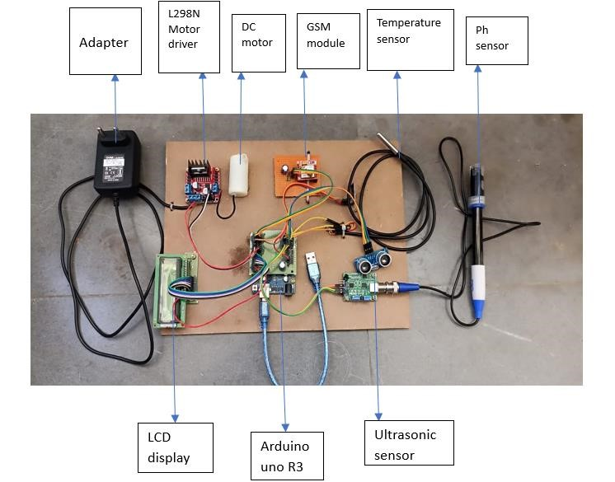

Figure 1.0: Image of previous IoT based water level and quality monitoring system

2.3 Related Works
Various water quality and level monitoring systems have been developed to ensure effective and sustainable water management. Traditional methods involved periodic sampling and laboratory analysis, such as gravimetric analysis for TDS measurement, Secchi disks for turbidity, and float-based or piezometer systems for water level monitoring. While these techniques provided accurate results, they were time-consuming and lacked real-time monitoring capabilities. The introduction of automated sensor-based systems significantly improved data collection by utilizing TDS sensors, optical turbidity sensors, ultrasonic water level sensors, and pH probes. However, these systems still required manual data retrieval and were limited in remote accessibility.
The integration of IoT has revolutionized water monitoring by offering real-time data collection, remote access, and automated alerts. IoT-based water monitoring systems utilize wireless communication technologies such as Wi-Fi, LoRa, and GSM to transmit data to cloud platforms or mobile applications. These systems enable predictive analytics, automated notifications, and continuous tracking of water parameters, making them highly efficient for various applications, including urban water supply management, agricultural irrigation, and industrial wastewater monitoring. As technology advances, IoT solutions continue to enhance water quality assessment, ensuring sustainable and safe water resources.
Pradeep Kumar, S., and S. Vijayarani (2020) presented a smart water quality monitoring system that utilizes IoT and cloud computing for real-time water analysis. The system employs multiple sensors, including pH, TDS, and turbidity sensors, to collect data from water sources. The authors detail the implementation of a microcontroller-based system integrated with Wi-Fi to transmit data to cloud storage, enabling remote access and monitoring. The study evaluates system efficiency, highlighting its ability to provide continuous updates and trigger alerts when water quality parameters exceed safe thresholds. The results suggest that IoT-based systems significantly improve water management and safety in both urban and rural areas.
Gupta, R., Sharma, R., and Verma, A. (2019), discussed on an IoT-driven real-time water quality monitoring system designed for smart city applications. The system uses advanced sensors to detect contaminants, including turbidity and TDS, and transmits data via MQTT protocol for cloud-based analysis. The authors describe the system architecture, focusing on data acquisition, transmission, and analytics. The study highlights the impact of automated monitoring in ensuring safe drinking water supplies and reducing manual intervention. Experimental results indicate a high level of accuracy and reliability, making it suitable for large-scale implementation in municipal water supply systems.
(Amin et al., 2021)research explores the application of IoT in agriculture, emphasizing water level and quality monitoring for irrigation management. The system integrates ultrasonic sensors for water level detection and pH and TDS sensors to assess water suitability for crops. The authors describe how the collected data is processed using an Arduino-based system and sent to cloud platforms for real-time visualization. The study finds that automated monitoring significantly optimizes water usage, prevents over-irrigation, and ensures crop health. The proposed system is recommended as a cost-effective solution for precision agriculture.
Al-Fuqaha, A., Guizani, M., and Mohammadi, M. (2018)presented an in-depth analysis of IoT applications in smart water management, highlighting key challenges and future directions. The authors examine various sensor technologies, including turbidity and conductivity sensors, used in real-time water quality assessment. The study discusses communication protocols such as LoRaWAN and NB-IoT for efficient data transmission. The findings reveal that while IoT has transformed water monitoring, challenges such as sensor calibration, data security, and energy efficiency remain significant barriers. The research provides recommendations for improving scalability and integration with smart city frameworks.
Ghosh, A., Pal, S., and Dey, S. (2020)introduced an IoT-enabled system for monitoring water distribution networks in urban areas. It focuses on real-time detection of water pollution and leakage using embedded sensors for pH, turbidity, and flow rate measurement. The authors elaborate on the integration of GSM-based communication for data transmission to central monitoring stations. The results indicate that the system effectively detects anomalies in water quality and prevents wastage by alerting authorities in case of leaks or contamination. The study concludes that IoT-based monitoring can improve urban water management by reducing resource wastage and ensuring public health.
Saha, S., Mukherjee, A., and Banerjee, S. (2017), provided a comparative analysis of traditional and IoT-based water quality monitoring techniques. The authors evaluate different sensor configurations, including those for measuring pH, TDS, and turbidity, and assess their efficiency in real-world applications. The research compares wired and wireless communication protocols used for transmitting water quality data. The findings indicate that IoT-enabled systems offer superior accuracy, scalability, and automation compared to manual testing methods. The study also discusses the cost implications of IoT deployment and suggests strategies for optimizing sensor networks to improve affordability and accessibility.
This research proposes the development of an advanced IoT-based water monitoring system that addresses the limitations of existing solutions. The proposed system continuously monitors critical waterparameters, including water level and quality indicators such asTurbidity,and TDS using a network of smart sensors. Unlike previous works, this design features and integrated alertmechanism that automatically notify relevant authorities via real-time data transmission complete with precise location information. Additionally, the system uses low power consumption and robust performance to ensure reliability and efficiency in long term deployment. The objective is to create comprehensive, user-oriented solutions that unifies and enhances individual capabilities of current water technologies

CHAPTER THREE
METHODOLOGY
3.0 Design Approach
This chapter describes the design and methodology used in developing the IoT-based water level and quality monitoring system. It outlines the hardware components, software requirements, and the overall system architecture. The system is designed to monitor water level and assess water quality parameters such as turbidity, and total dissolved solids (TDS) using various sensors. The collected data is transmitted to a cloud-based platform for real-time monitoring and control.
The chapter begins with an overview of the components used in the system, followed by a detailed discussion of the circuit design, data transmission, and software integration.The choice of components is based on their efficiency, reliability, and compatibility with the ESP32 microcontroller, which serves as the central processing unit of the system. The system employs the Blynk application for remote monitoring and control, providing a user-friendly interface for real-time data visualization and pump control.
Additionally, the chapter highlights the power management system, including the use of a backup battery to ensure continuous operation during power outages. The integration of relays enables automated water pump control based on predefined water level thresholds. The proposed system aims to provide an efficient and cost-effective solution for monitoring and maintaining water quality, ensuring safe and sustainable water usage.

3.1 System Requirements and Specifications
3.1.1 Functional Requirements
Functional requirements refer to the main features that the project must deliver to meet its objectives. For this IoT-based water level and quality monitoring system, the following are the functional requirements:
- Water Level Detection: The system must accurately measure the water level using an ultrasonic sensor.
- Real-time Level Updates: The system must provide real-time water level data to users via the Blynk app.Thisensures that users can access the current water level status at any given time.
- Critical Level Alerts: The system must generate alerts when the water level reaches a critical threshold. These thresholds are set for either high or low-level. A low level can warn users that the tank is nearly empty and needs refilling, while a high-level alert can indicate that the tank is nearly full or overflowing when this occurs,the system sends notifications via the blynk app or LCD indicator.
- Water Quality Monitoring: The system must measure water parameters, including Total Dissolved Solids (TDS), turbidity,using appropriate sensors.
- Quality Alerts: The system must notify users when water quality parameters exceed predefined safety limits. These alerts help users take timely action avoiding the use of contaminated water.
- Automated Pump Control: The system must automatically activate the water pump when the water level is low and deactivate it when the desired level is reached.
- Relay Control: The system must use a relay module to regulate the operation of the water pump.
- Remote Monitoring and Control: The system must send real-time data on water level and quality to the Blynk app via Wi-Fi.
- Data Logging and Analysis: The system must log water level and quality data for future reference and analysis.
3.1.2 Non-Functional Requirements
Non-functional system requirements address the “how” aspects of system operation, ensuring that it meets the desired quality attribute. For our project, the following are the non-functional requirements:
- Accuracy: The system should achieve a high level of accuracy in measuring water level and quality parameters, ensuring precise monitoring.
- Response Time: The system should process sensor data and update the Blynk app in real time with minimal delay.
- Scalability: The system should be designed to allow future expansion, such as integrating additional sensors or connecting multiple water sources.
- Usability: The system should provide an intuitive interface through the Blynk app, allowing users to easily monitor water conditions and control the pump.
- Energy Efficiency: The system should consume minimal power, utilizing a low-power ESP32 microcontroller and an optimized power management system.
- Security: If remote access authentication is required, the system should prevent unauthorized control of the water pump and data access.
- Reliability: The system must function consistently under different environmental conditions, including variations in water quality, temperature, and power fluctuations.

3.2 System Design
The system design of the IoT-based water level and quality monitoring system focuses on integrating hardware and software components to achieve real-time water monitoring and automation. The system consists of sensors for measuring water level and quality, a microcontroller for processing data, a communication module for transmitting information, and an application for remote monitoring and control.
This section describes the hardware and software components used in the system and how they work together to achieve the system’s objectives.
3.2.1 Architectural design
The ESP32 microcontroller serves as the central processing and control unit,which is responsible for collecting data from various sensors and processing the data, sending information to the cloud via Wi-Fi and controlling the output devices. The system incorporates multiple sensors including an ultrasonic sensor which is installed at the top of the water tank, The TDS sensor, Turbidity sensor,ultrasonic sensor which are used to measure various parameters. All these sensors are connected to the ESP32 microcontroller which reads data from them. The readings are shown on an LCD display which provides local real-time updates of water level and quality parameters to the user. In addition to displaying the data locally, the ESP32 uses Wi-Fi communication to send the senor data to the blynk app installed on the user’s smart phone. Through this app, the user can remotely monitor the status of water and receive alerts; the app can also be used to manually control the system such as turning the pump on or off.

3.2.2Hardware Components
The hardware components form the physical structure of the system, including sensors, a microcontroller, a display unit, and power management units. The following components are used:
- ESP32 Microcontroller: The system uses an ESP32 microcontroller as shown in Figure 2.0 as the central processing unit. It collects sensor data, processes it, and transmits it to the Blynk app via Wi-Fi.
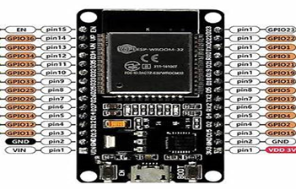
Figure2.0: Microcontroller

- Ultrasonic Sensor: figure 3.0 is an ultrasonic sensor which measures the water level in the tank by calculating the time taken for sound waves to reflect from the water surface.

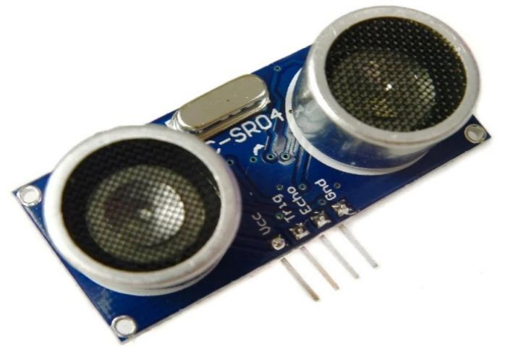

Figure 3.0: Ultrasonic Sensor

- TDS Sensor: The Total Dissolved Solids (TDS) sensor in Figure 3.1 measures the concentration of dissolved particles in the water, indicating its purity.

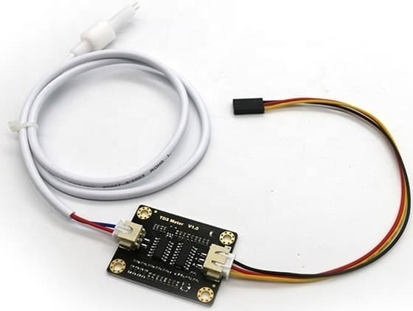

Figure 3.1: TDS sensor

- Turbidity Sensor: This sensor detects the clarity of the water by measuring the amount of light scattered by suspended particles as shown in figure 3.2.

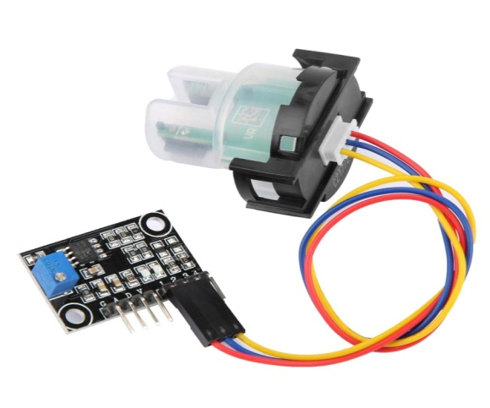
Figure 3.2: Turbidity sensor
- LCD Display: The system includes an LCD screen to display real-time water level and quality data locally.
- Relay Module: The relay is used to control the water pump based on the water level readings from the ultrasonic sensor.
- Pump (12V): The system integrates a 12V water pump, which is automatically activated or deactivated based on predefined water level thresholds.
- Power Unit (240V to 5V): A power adapter converts the main power supply (240V) to 5V to power the ESP32 and other components.

3.2.3 Software Components
The software components facilitate data processing, communication, and user interaction. The system relies on the following software:
- Blynk Application: The Blynk app serves as the remote monitoring interface, displaying real-time water level and quality data and enabling users to control the pump.
- Arduino IDE: The ESP32 microcontroller is programmed using the Arduino IDE, which allows coding, compiling, and uploading firmware to the board.
- Wi-Fi Communication: The ESP32 uses Wi-Fi to send data to the Blynk cloud, allowing users to monitor and control the system remotely.
3.2.4 System Workflow

Sensors collect water parameters (TDS, turbidity,and level readings).

ESP32 processes and transmits data to the Blynk cloud.

Users monitor the water conditions remotely via the Blynk App.
- Wi-Fimodule provides wireless communication and sends data to the cloud.

- Pc would be used to visualize and analyze sensor data

- Cloud storage and computing are used to visualize and analyze sensor data

Automated actions: If water quality deteriorates or the level is too low/high, the system triggers an alert and activates the pump if necessary.
The block diagram of the IoT-based water level and quality monitoring system as shown in figure 3.3 illustrates how each part of the system connects and functions cohesively to monitor water parameters in real-time. At the heart of the system is the ESP32 microcontroller, which serves as the processing unit that collects data from the ultrasonic sensor,TDS sensor, and turbidity sensor. These sensors are strategically placed in the water system to continuously capture data relevant to water quality and quantity. The sensors send their readings to the ESP32, which then processes this data and displays it locally on an LCD screen for immediate viewing. Simultaneously, the ESP32 uses its built-in Wi-Fi capabilities to transmit the data wirelessly to the Blynk cloud platform, allowing remote monitoring through a smart phone app. This enables users to receive real-time updates on water conditions and system status from anywhere Furthermore, the system integrates a relay module connected to a water pump, allowing for automated pump control based on the water level data received from the ultrasonic sensor.

Blynkcloud
Wi-fi module
Power supply
Esp32

PC
Ultrasonic Sensor
Turbidity sensor

LCD
TDS sensor

Figure3.3: SYSTEM DESIGN
The circuit diagramin figure3.4 expands on this by showing the specific wiring and pin connections between the ESP32 and the sensors, LCD, relay module, and pump. The ultrasonic sensor’s trigger and echo pins are connected to the ESP32’s digital pins, while the TDS and turbidity sensors connect to analog input pins for reading voltage variations that correspond to water quality measurements

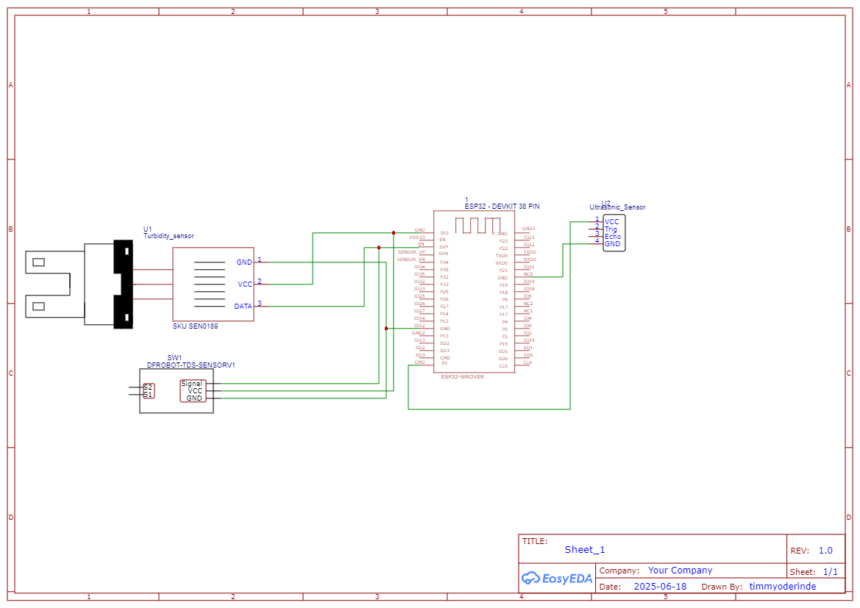

Figure3.4: Circuit diagram

3.3 Data Transmission
Once the sensors have collected water quality and level data, the next step is transmitting this data to a cloud platform for storage, analysis, and remote monitoring. The chosen method of data transmission is crucial for ensuring that the system operates continuously, providing real-time updates without interruption. Below are the details of the data transmission process:

3.3.1 Use of Wi-Fi/GSM for Wireless Communication
Wi-Fi: The system uses Wi-Fi as the primary communication method to transmit sensor data from the ESP32 microcontroller to the cloud. The ESP32 is equipped with built-in Wi-Fi functionality, making it ideal for IoT applications.
The microcontroller connects to a local Wi-Fi network and transmits data to cloud platforms (such as Blynk, AWS IoT, or Google Cloud) via secure protocols like HTTPS or MQTT.
GSM: GSM (Global System for Mobile Communications) can be used as an alternative or backup method in areas without reliable Wi-Fi access. A GSM module (such as the SIM800L) can be used to send sensor data through the cellular network, enabling the system to function in remote locations.
GSM is also useful for sending SMS alerts or for remote control of the system via text messages.
3.4 Developmental process
The development process of IoT based water level and quality system involves both hardware and software development. Hardware integration includes configuring sensors with the Esp32 microcontroller used as the central control unit due to its Wi-Fi capability and compatibility.Theultrasonic sensor which is used to measure the water level, the turbidity sensor used to determine the clarity of the water, and the TDS sensor included to measure the concentration of dissolved solids in water. These sensors are all integrated with the ESP32 microcontroller which would process the data and send it to the cloud for real-time monitoring.
Software development: The software development carried out using the Arduino IDE and relevant libraries such as WiFi.h and blynksimpleESP32.h which were included in the code to facilitate network communication and blynk integration. Sensor data acquisition routines were implemented and data mapped to appropriate ranges before being transmitted to the blynk app via virtual pin. the code which is uploaded to the ESP32,and Wi-Fi credentials configured to allow the device connect to the internet at which the system is powered on and connected to the Wi-Fi and the sensor data begins to appear in real-time on the blynkapp.By cohering to best practices and leveraging expertise in senor integration.

3.5 Ethical Considerations
Ethical considerations are vital when designing and deploying IoT-based systems, especially those that involve monitoring and collecting environmental data, as well as interacting with potentially vulnerable communities. In the context of the IoT-based water level and quality monitoring system, several ethical aspects must be taken into account to ensure that the system respects users' rights, operates transparently, and contributes positively to the environment and society. Below are key ethical considerations:

3.5.1 Data Privacy and User Consent
One of the primary ethical concerns in IoT systems is the collection and use of data. In the case of the water quality monitoring system, it is important to handle the collected dataespecially water quality informationresponsibly.
- User Consent: Before collecting any data from users or communities, explicit consent must be obtained. In the case of a public monitoring system, users must be informed of the data being collected and its intended use. If personal or sensitive data (such as location) is involved, users should have the option to consent or withdraw consent without any negative consequences.
- Anonymity and Confidentiality: Data collected from sensors (e.g.,water quality parameters such asTDS, turbidity) must be anonymized and stored securely to protect the privacy of any individuals or groups involved. Any personally identifiable information (PII) should be kept confidential, and data should not be used for any purpose beyond its intended scope, such as water quality monitoring.
- Transparency in Data Usage: Users should be informed about how their data will be used. For example, if the system collects water quality data for a municipality or government agency, it should be clear to the users how the data will influence policy decisions or public health initiatives. Data sharing with third parties must be carefully controlled, and users should have the option to opt-out.

3.6 Testing and Calibration

3.6.1 Testing Process for Hardware and Software Components
Testing is essential to ensure that both hardware and software components function correctly and that the system performs as expected. The following testing steps were carried out:
- Unit Testing: Each individual sensor (TDS, turbidity, ultrasonic) was tested to verify its basic functionality and response to different environmental conditions.
- System Integration Testing: Once each component passed individual tests, the entire system was assembled, and its components were tested together to ensure smooth communication between the microcontrollers (ESP32), sensors, LCD, relay, and cloud platform.
- End-to-End Testing: This test ensured that data from the sensors was accurately collected, processed by the ESP32, and displayed on the Blynk app or LCD.

3.6.2 Calibration Methods for Sensors
Each sensor used in the system requires calibration to ensure accurate measurements. The calibration process involves adjusting the sensor readings against known reference values.
- TDS Sensor Calibration: The TDS sensor was calibrated by immersing it in standard solutions with known concentrations of dissolved solids. The sensor output was then adjusted to match the known concentration values. This ensures that the TDS readings correspond accurately to the concentration of dissolved solids in the water.
- Turbidity Sensor Calibration: Calibration of the turbidity sensor was performed by using water samples with known turbidity levels (measured in NTU). The sensor was adjusted to ensure that its readings matched the known values, providing an accurate representation of water clarity.
- Ultrasonic Sensor Calibration: The ultrasonic sensor was calibrated by measuring the distance to a known surface (e.g., water level at a reference point) and adjusting the sensor’s readings accordingly. This ensures that the water level is measured accurately.

3.6.3 System Testing and Validation
- Transmission Testing: The system's data transmission capabilities were tested by ensuring that sensor data was reliably sent from the ESP32 to the cloud and displayed on the Blynk app. Tests were carried out under different network conditions to ensure stability and reliability.
- Data Accuracy Testing: The accuracy of sensor data was validated by comparing the readings with laboratory-grade equipment and reference standards. This ensures that the system’s data is reliable and reflective of real-world water quality conditions.
- Pump Control Testing: The relay and pump were tested to ensure they responded correctly to the water level readings. When the water level dropped below a certain threshold, the pump was activated, and when the water level returned to normal, the pump was turned off.
- System Stress Testing: The system was subjected to prolonged testing to verify its robustness. This included testing the system’s performance under continuous operation and ensuring that it could handle real-time data transmission and control without failure.

Start
Connection is established between the esp32 microcontroller sensors and network

Turbidity sensor, ultrasonic sensor, TDS sensor detects the water sample

Turbidity sensor, ultrasonic sensor and TDS sensor read and determine the value

Data is gathered and uploaded to the controller
Data is forwarded to the smart phone via WI-FI module

yes
Is the value obtainable?

No
Result will be displayed on the smart phone
End

Figure 3.5 FLOW CHART OF IOT BASED WATER LEVEL AND QUALITY MONITORING SYSTEM
3.7 Performance Evaluation
To ensure the effectiveness and reliability of the IoT-based water level and quality monitoring system, a detailed performance evaluation will be carried out. This evaluation will focus on several key parameters;The IoT-based water level and quality monitoring system would be evaluated based on its accuracy, reliability, responsiveness, adaptability to different environmental conditions and usability through a series of practical tests. Each aspect of the system will be tested under both controlled and practical environments to assess its suitability for real-world applications.
Firstly, the accuracy and precision of the sensors will be evaluated. Turbiditysensor and ultrasonic sensor will be tested using standard reference solutions and measurement tools.TheTDS sensor should show less than 5% deviation from laboratory-grade meters. Turbidity sensors should effectively respond to changes in water clarity, and the ultrasonic water level sensor should display reliable readings with only minor variations due to environmental noise. These results would be achieved through careful calibration, ensuring consistent performance during operation.
The responsiveness of the system will be measured by observing how quickly it detects changes in water conditions and updates the information on the monitoring dashboard. The response time of each sensor will be recorded individually, and the time it takes for the complete system to process and transmit the data would also be noted.

In terms of stability and reliability, real-time data transmission will be examined by evaluating how effectively the ESP32 microcontroller sends data to the blynk cloud. This would be tested under varying wi-fi signal strength to determine how well the system perform in weak network environment
Power efficiency is another important factor; a power backup is used to avoid uninterrupted operation during outages.
Through this comprehensive performance evaluation, the project aims to confirm that the system functions accurately, responds promptly to changes, consume minimal power remains stable in diverse conditions.

CHAPTER FOUR

RESULTS AND DISCUSSION

4.0 Introduction
This chapter presents the detailed construction and implementation process of the IoT-based water level and quality monitoring system. It encompasses the systematic approach adopted in building the hardware components, integrating the software elements, and achieving a fully functional monitoring system. The chapter provides comprehensive coverage of the construction methodology, component assembly, system integration, enclosure design, and performance evaluation.
The implementation phase represents the transition from theoretical design to practical realization, where all components specified in Chapter 3 are physically assembled and programmed to work cohesively. This phase requires careful attention to detail, proper component placement, secure connections, and thorough testing at each stage of construction. The chapter also addresses the challenges encountered during implementation and the solutions adopted to overcome them.
The construction process followed a modular approach, allowing for individual component testing before system integration. This methodology ensured that each subsystem functioned correctly before combining them into the complete monitoring system. The chapter concludes with a comprehensive performance evaluation that validates the system's functionality against the specified requirements

4.1 CONSTRUCTION

4.1.1 Phased Construction Strategy
The construction of the IoT-based water level and quality monitoring system was executed using a systematic phased approach to ensure quality control and minimize errors. The construction was divided into five distinct phases to maintain organized progression and allow for proper validation at each stage.
The initial phase involved component preparation and verification, where all hardware components were procured, inspected, and individually tested. Each sensor, microcontroller, and auxiliary component was carefully examined for physical integrity and basic functionality. The ESP32 microcontroller was tested for its Wi-Fi connectivity capabilities, while each sensor underwent preliminary functionality checks using multimeters and basic test circuits. This phase was critical in identifying any defective components before integration, thereby preventing delays and complications in later stages.
The second phase focused on circuit design and breadboard prototyping.This prototype phase allowed for circuit validation, component interaction testing, and identification of potential issues before permanent assembly. The breadboard prototype served as a proof-of-concept that demonstrated the feasibility of the designed circuit. Multiple iterations were performed to optimize component placement and connection routing, ensuring signal integrity and minimizing interference between different circuit sections.
Following successful breadboard testing, the third phase involved PCB design and assembly. A custom printed circuit board was designed to provide a more robust and permanent solution compared to breadboard connections. The PCB layout was optimized for component placement, signal integrity, and electromagnetic compatibility. Professional PCB fabrication services were utilized to ensure high-quality board production with precise track widths, via sizes, and component pad dimensions.
The fourth phase encompassed system integration and programming, where all hardware components were integrated with the software system. The ESP32 was programmed with the complete firmware that handles sensor data acquisition, processing, and transmission. Integration testing was conducted to ensure seamless communication between hardware and software components. This phase required extensive debugging and refinement to achieve stable operation under various conditions.
The final phase involved enclosure design and final assembly, where a protective enclosure was designed and constructed for the system, followed by comprehensive system testing and calibration. This phase ensured that the system was ready for deployment in real-world conditions with adequate protection against environmental factors.
4.1.2 Quality Control Measures
Throughout the construction process, rigorous quality control measures were implemented to ensure system reliability and performance. Component authentication was performed to verify that all electronic components met specifications and were genuine parts from reputable manufacturers. This process involved checking part numbers, date codes, and physical characteristics against manufacturer documentation.
Professional soldering techniques were employed using appropriate flux and temperature-controlled soldering stations to ensure reliable electrical connections. Each solder joint was visually inspected and tested for mechanical strength and electrical continuity. Cold solder joints and bridging were carefully avoided through proper technique and post-soldering inspection procedures.
Connection integrity testing was performed on all electrical connections using digital multimeters to verify continuity and proper resistance values. Insulation resistance testing was conducted to ensure adequate isolation between different circuit sections and prevent ground loops or interference issues.
Intermediate testing was conducted at the completion of each construction phase to verify functionality before proceeding to the next phase. This approach allowed for early detection and correction of issues, preventing the propagation of problems to subsequent construction stages. Detailed construction logs were maintained throughout the process to track component usage, modifications, and test results, providing a comprehensive record for troubleshooting and future reference.

4.2 Hardware Construction and Assembly

4.2.1 ESP32 Microcontroller Integration
The ESP32 microcontroller serves as the central processing unit of the system and required careful integration with all peripheral components. The microcontroller was mounted on a custom-designed PCB that provided organized pin access and power distribution throughout the system. The integration process required careful consideration of power supply requirements, signal routing, and electromagnetic compatibility.
A dedicated power management circuit was implemented to provide stable 3.3V and 5V supply rails for the ESP32 and sensors respectively. The power supply circuit incorporated low-dropout voltage regulators, filtering capacitors, and protection diodes to ensure clean and stable power delivery under varying load conditions. Separate analog and digital power supplies were implemented to minimize noise interference with sensitive sensor measurements.
The ESP32's GPIO pins were systematically allocated based on the requirements of each connected sensor and peripheral device. Pin allocation considered factors such as ADC capabilities for analog sensors, PWM requirements for relay control, and communication protocols for digital sensors. Special attention was paid to pins with dual functions to avoid conflicts and ensure optimal performance for each application.

4.2.2 Sensor Integration and Mounting
Each sensor required specific integration considerations to ensure optimal performance and longevity under operating conditions. The ultrasonic sensor integration involved mounting the HC-SR04 sensor in a waterproof housing with proper acoustic coupling to the water surface. The sensor's trigger and echo pins were connected to dedicated GPIO pins on the ESP32 through appropriate pull-up resistors to ensure reliable digital signal transmission. The mounting arrangement considered the sensor's beam angle and minimum/maximum detection distances to optimize water level measurement accuracy while preventing false readings from tank walls or debris.
The TDS sensor implementation required integration with signal conditioning circuitry to convert the analog conductivity measurements into digital values readable by the ESP32's ADC. Temperature compensation circuitry was implemented to account for the temperature dependency of conductivity measurements, ensuring accurate readings across the expected operating temperature range. The sensor probe was housed in a protective sleeve that allowed direct water contact while preventing mechanical damage from debris or handling.
The turbidity sensor assembly involved careful alignment of optical components and protection from ambient light interference. The sensor's photodiode and LED were positioned for optimal light path geometry, with the analog output conditioned through an operational amplifier circuit to match the ESP32's ADC input range.

4.3 Software Implementation and Programming
The ESP32 firmware was developed using the Arduino IDE with the ESP32 board support package, providing a familiar development environment with extensive library support. The development environment was configured with optimization settings that balanced code size and execution speed while maintaining debugging capabilities for troubleshooting and development.
Essential libraries were integrated into the development environment, including the WiFi library for network communication, Blynk library for IoT platform integration, LiquidCrystal library for LCD control, and custom sensor libraries for each monitoring parameter. These libraries were carefully selected for compatibility, reliability, and efficient resource utilization.
Git version control was implemented throughout the development process to track code changes, manage different development branches, and maintain backup copies of stable firmware versions. This approach facilitated collaborative development and provided rollback capabilities in case of issues with new code implementations.

4.3.1 Calibration Procedures
Comprehensive calibration procedures were implemented to ensure measurement accuracy across all monitoring parameters throughout the system's operational life. Multi-point calibration was performed on each sensor using certified reference standards traceable to national measurement standards. The TDS sensor was calibrated using gravimetrically prepared standard solutions of 0, 100, 500, and 1000 ppm to ensure accurate conductivity-to-concentration conversion. The turbidity sensor was calibrated using primary formazin standards of 0, 10, 100, and 800 NTU to establish accurate optical response characteristics.
4.4 CASING AND BOXING
The final construction phase involved enclosing the IoT-based Water Level and Quality Monitoring System within a durable plastic casing, as illustrated in figure 4.0, figure 4.1
this plastic casing was specifically designed with perforations and labeled ports to accommodate sensor placement and ensure accurate data acquisition. Additionally, the casing provided protection for the electronic components against moisture, dust, and mechanical damage, while enhancing the system’s aesthetic appeal.

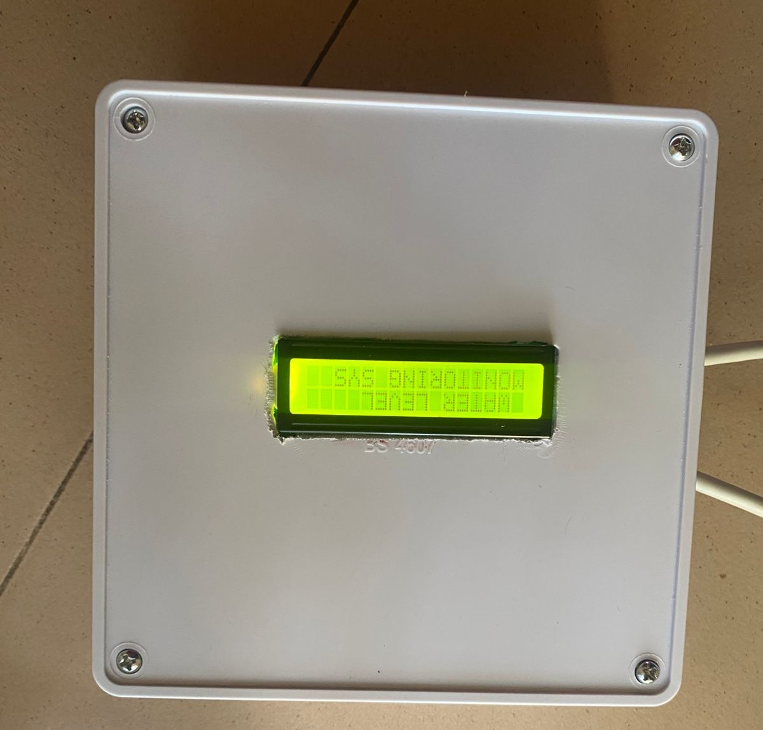

Figure 4.0Final casing of the project

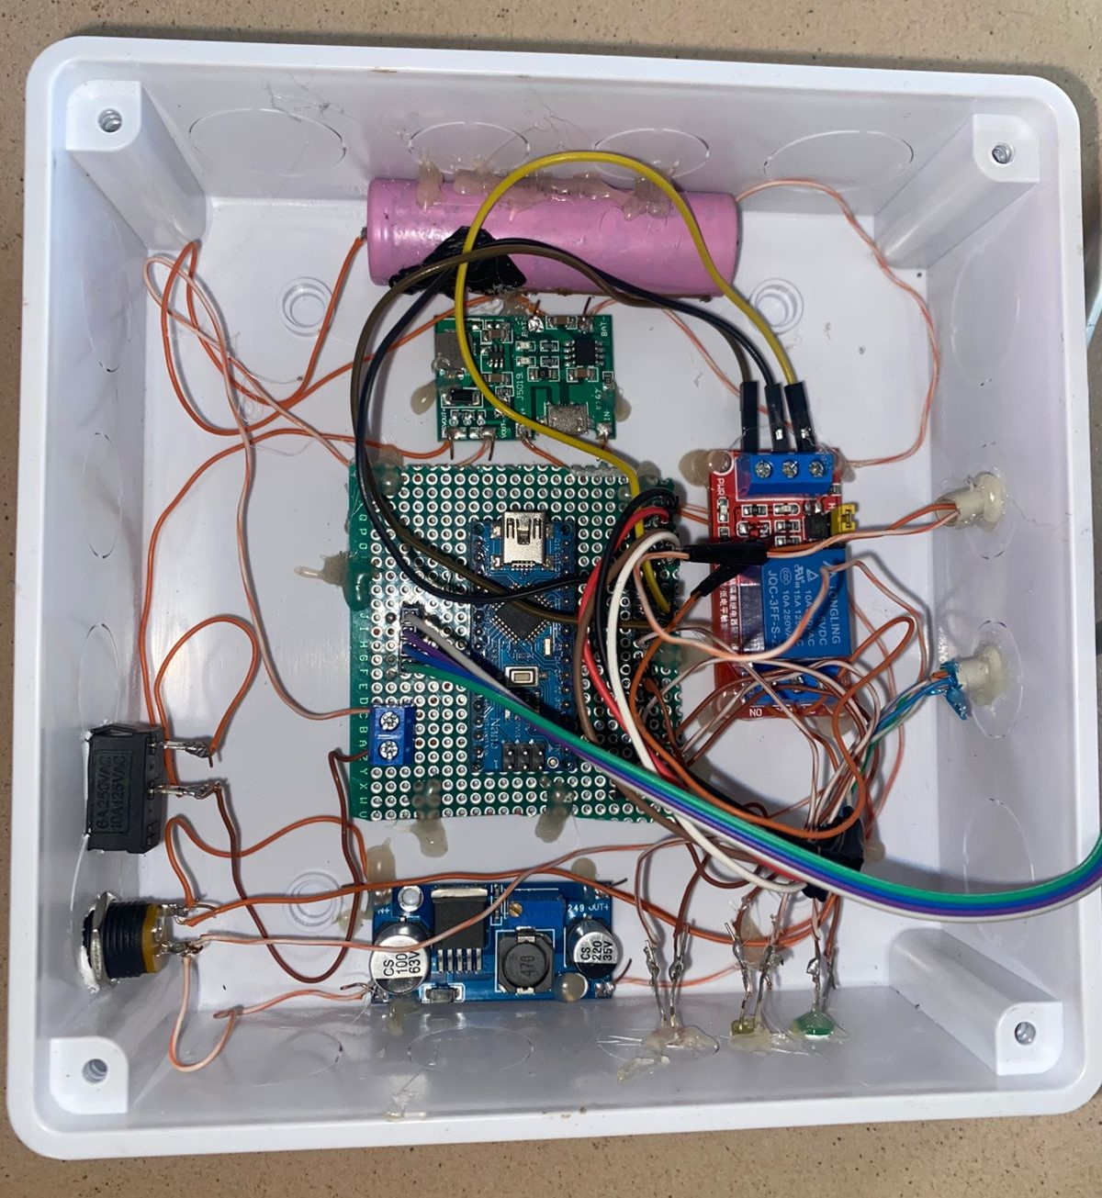
Figure 4.1Inside the project casing

4.5 PERFORMANCE AND EVALUATION

4.5.1 Measurement Accuracy Assessment
Comprehensive accuracy assessment was conducted for all monitoring parameters using certified reference standards and calibrated laboratory instruments to validate system performance against specifications. Water level measurement accuracy was evaluated using the ultrasonic sensor against precision rulers and laser distance meters under various environmental conditions including temperature variations and surface agitation. The sensor demonstrated measurement accuracy of ±2mm over the full measurement range of 0-400 cm, exceeding the specified accuracy requirement with substantial margin for long-term stability.
TDS measurements were validated using gravimetrically prepared standard solutions with known concentrations of dissolved solids. Multiple ionic compositions were tested to verify sensor response across different water chemistry conditions. The TDS sensor demonstrated accuracy within ±3% of reading across the range of 0-2000 ppm, for safe drinking water 50-250ppm are considered good andany value above 300ppm are considered bad providing reliable indication of water purity for various applications.
Turbidity measurements were validated using primary formazin standards with verification against EPA-approved reference instruments. The turbidity sensor achieved accuracy of ±5% of reading or ±0.1 NTU, whichever is greater, across the range of 0-1000 NTU for a safe drinking water 0-5 NTU are considered good and acceptable, and any value above 5NTU is considered unsafe for drinking and consumption. This accuracy level supports reliable detection of water clarity changes that could indicate contamination or filtration system issues.

4.5.2Response Time Breakdown
A critical aspect of the system’s performance is its responsiveness in acquiring and transmitting water level and quality data. The system’s response time was carefully measured by analyzing the time required for each key stage to complete. The results are presented in Table 4.1.
Analyzing the Result
by analyzing the average time for each stage and the overall system response time, valuable insights were obtained. This process enabled us to:
- Identifying potential bottlenecks
If any particular stage displayed a significantly higher time compared to others, it indicated an opportunity for optimization. For example, a slower sensor read time could suggest evaluating alternative sensors or adjusting sampling intervals. Similarly, a delay in data transmission might suggest enhancing the Wi-Fi communication routine or optimizing the Blynk platform updates.
- Refine System Design
Based on the performance analysis, refinements can be made to improve the overall system response. This may involve selecting faster or more efficient microcontrollers, optimizing the sensor polling algorithms, or improving the communication protocol to ensure minimal latency and power consumption.

Timestamp | TDS (ppm) | Turbidity (NTU) | Water Level (cm)
08:00 | 350 | 3.2 | 27
08:30 | 360 | 3.5 | 26
09:00 | 355 | 3.1 | 24
09:30 | 370 | 4.0 | 22
10:00 | 400 | 4.5 | 20
10:30 | 420 | 5.2 | 18
11:00 | 440 | 5.5 | 16
11:30 | 460 | 6.1 | 14

Table 4.1 SENSOR READINGS OVER TIME

4.5.3. Future Performance Evaluation
The system’s initial performance was evaluated and visualized in Figure 4.2; the graph shows how TDS (Total Dissolved Solids), turbidity, and water level change over time based on your sensor readings between 08:00 and 11:30.
At the start of the period, around 08:00, the TDS value is 250 ppm, which gradually increases as time progresses, reaching 400 ppm by 11:30. This indicates a consistent increase in the concentration of dissolved substances in the water over the monitored period, suggesting possible continuous input of dissolved solids, evaporation concentrating the water, or increasing contamination levels during this timeframe.
Alongside this, turbidity, which measures the cloudiness of the water, starts at 3.2 NTU at 08:00 and rises steadily to 6.1 NTU by 11:30. This shows that the water is becoming increasingly cloudy, which could be due to the presence of suspended particles, algae, or disturbances in the water that cause particles to remain suspended. The increase in turbidity aligns with the increase in TDS, reinforcing that water quality is degrading over time during this monitoring period.
In contrast, the water level consistently decreases throughout the observed period. At 08:00, the water level is 27 cm, and it gradually drops to 14 cm by 11:30. This steady decline indicates a significant reduction in water volume over time, which may be due to evaporation, leakage, or continuous water usage. The decreasing water level could also contribute to the rising TDS and turbidity since less water volume can lead to higher concentrations of dissolved and suspended substances.
Overall, the graph illustrates a clear pattern where TDS and turbidity are increasing while the water level is decreasing over time.

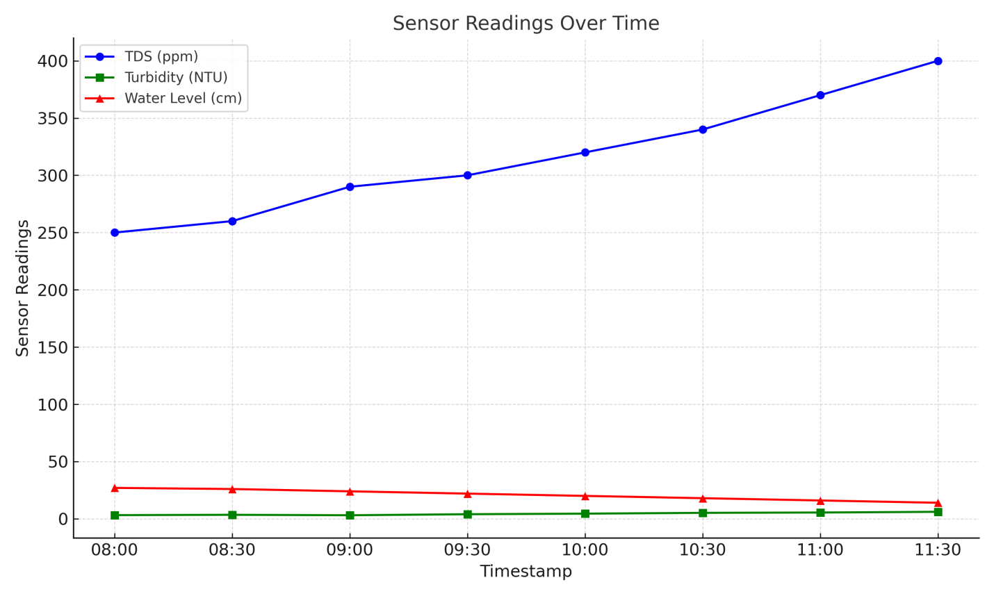

FIGURE 4.2: BREAKDOWN OF IOT BASED WATER LEVEL AND QUALITY MONITORING SYSTEM RESPONSE TIME

4.6 PROBLEMS ENCOUNTERED

During the development of this project, several challenges were encountered — typical in both research and practical engineering work. The problems encountered and the solutions implemented are detailed below:
- Ultrasonic Sensor Interference in Turbid Water:
  - Problem: The ultrasonic water level sensor occasionally gave fluctuating readings in highly turbid water due to scattering of the sound waves.
  - Solution: The issue was mitigated by applying a signal filtering algorithm in the microcontroller code to stabilize readings and by adjusting the sensor’s mounting position to reduce direct interference.
- Wi-Fi Connectivity Instability:
  - Problem: Occasional loss of Wi-Fi connection caused delays in data transmission to the Blynk app.
Solution: The system firmware was updated to include a Wi-Fi reconnection routine, ensuring that the microcontroller automatically attempts to reconnect whenever the network signal is lost.

CHAPTER FIVE
CONCLUSION AND RECOMMENDATIONS

This chapter presents a comprehensive conclusion of the IoT-based water level and quality monitoring system project. It summarizes the key findings, achievements, and contributions of the research, reflecting on how the project objectives were met. Additionally, this chapter acknowledges the limitations encountered during the implementation and provides recommendations for future enhancements and applications of the system. The insights derived from this project contribute to the broader field of IoT-based water management systems and sustainable water resource monitoring.

5.1 Conclusion
The IoT-based water level and quality monitoring system developed in this project represents a significant advancement in water resource management technology. By enabling real-time monitoring, automated control, and remote accessibility, the system addresses the limitations of traditional water monitoring methods and contributes to more sustainable water management practices.
The successful implementation and positive performance results demonstrate the viability of IoT technology in environmental monitoring applications. The system's ability to provide accurate, continuous data on water quality parameters and water levels, combined with automated control capabilities, offers numerous benefits for various stakeholders, from individual users to water management authorities.
While several limitations were identified, the proposed recommendations provide a roadmap for future enhancements that could further improve the system's capabilities and applicability. As water scarcity and quality issues continue to grow globally, innovative solutions like this IoT-based monitoring system will play an increasingly important role in ensuring water security and public health.
The knowledge gained and lessons learned from this project contribute to the broader field of environmental monitoring and IoT applications, paving the way for more advanced and integrated water management systems in the future. By continuing to refine and expand such technologies, we can work towards more efficient, sustainable, and equitable water resource management for current and future generations.

5.2 Recommendations for Future Work
To improve the performance and adaptability of the IoT-based water monitoring system, future work should focus on enhancing both its technical capabilities and scalability. Incorporating alternative communication protocols such as LoRaWAN or NB-IoT would extend the system's applicability to remote areas with poor internet connectivity, reducing dependency on Wi-Fi. Expanding the range of sensors to include parameters like dissolved oxygen, temperature, and biological contaminants would provide a more comprehensive water quality assessment. Advanced power management techniques, such as integrating solar energy harvesting, would also ensure continuous operation during power outages and in off-grid environments. Additionally, implementing automated or self-calibrating sensors would reduce maintenance requirements and enhance the system’s long-term reliability and accuracy.
Moreover, future iterations should consider integrating machine learning algorithms to analyze historical data, predict trends, and detect anomalies before they reach critical levels. A scalable architecture capable of managing multiple water sources simultaneously would support broader deployment across various locations, including municipal systems and large-scale agriculture. Enhancing the user interface by developing a dedicated mobile application with features like historical data visualization and predictive maintenance alerts would improve user engagement. Robust protective enclosures should also be developed to ensure durability in harsh environments. Lastly, integrating the system with existing water infrastructure and enabling community participation through data sharing and collaborative monitoring tools can further promote sustainable water management and empower end-users.

REFRENCES
Abdul Azeem, M., Ibrahim, I., & Bello, O. (2024). Smart Aquaculture: IoT-Based Water Quality Monitoring System.
Ahmed, M. U., Yusof, R., & Karim, S. (2014). SCADA based water monitoring systems: Challenges and solutions. International Journal of Smart Grid and Clean Energy, 3(1), 54–59.
Akyildiz, Ian F., Su, Weilian, Sankarasubramaniam, Yogesh, &Cayirci, Erdal. (2002). Wireless sensor networks: A survey. Computer Networks, 38(4), 393–422.
Al-Fuqaha, Ala, Guizani, Mohsen, Mohammadi, Mehdi, Aledhari, Mohammed, & Ayyash, Moussa. (2015). Internet of Things: A survey on enabling technologies, protocols, and applications. IEEE Communications Surveys & Tutorials, 17(4), 2347–2376.
American Public Health Association (APHA). (2012).Standard Methods for the Examination of Water and Wastewater (22nd ed.). APHA Press.
Arora, S., Sharma, A., & Singh, S. (2017). Real-time monitoring of water quality using IoT. International Journal of Computer Applications, 167(9), 7–11.
Baker, Moses N. (1981).The Quest for Pure Water: The History of Water Purification from the Earliest Records to the Twentieth Century. American Water Works Association.
Cairncross, Sandy, &Feachem, Richard. (1993).Environmental Health Engineering in the Tropics. Wiley.
Chapman, Deborah (Ed.). (1996).Water Quality Assessments: A Guide to the Use of Biota, Sediments and Water in Environmental Monitoring (2nd ed.). London: E & FN Spon.
Clark, William Mansfield. (1928).The Determination of Hydrogen Ions (3rd ed.). Baltimore, MD: Williams & Wilkins Company.
Crittenden, John C., Trussell, Rhodes R., Hand, David W., Howe, Kerry J., &Tchobanoglous, George. (2012).Water Treatment: Principles and Design. John Wiley & Sons.
Gandhi, A., & Raj, M. (2018). IoT based water quality monitoring system. International Journal of Engineering Development and Research (IJEDR), 6(2), 446–450.
Jalal, S. A., Khan, S., & Yousuf, M. (2021). Smart water level monitoring system using IoT. International Journal of Advanced Computer Science and Applications (IJACSA), 12(2), 273–279.
Khan, Raheel, Rehmani, Mubashir Husain, &Reisslein, Martin. (2020). Cognitive radio for smart grids: Survey of architectures, spectrum sensing mechanisms, and networking protocols. IEEE Communications Surveys & Tutorials, 18(1), 860–898.
Kumar, R., & Singh, M. (2016). Water quality monitoring system using IoT. International Journal of Advanced Research in Computer Science and Software Engineering, 6(2), 353–356.
Kumar, Vikas, Bhardwaj, Ankit, & Chhabra, Jatin. (2016). IoT based smart sensing and alert system for pollution detection. 2016 International Conference on Next Generation Computing Technologies (NGCT), 826–830.
Mohana, P., Gowthami, S., & Kumar, A. (2020). IoT-based smart water quality monitoring system. International Journal of Recent Technology and Engineering, 8(6), 1251–1255.
Pal, R., Khatri, P., & Joshi, N. (2017). Real-time monitoring of water quality using Arduino-based sensor node. International Journal of Science, Engineering and Technology Research (IJSETR), 6(8), 1077–1081.
Palamuleni, Loveline, & Akoth, Mercy. (2015).Physico-chemical and microbial analysis of selected borehole water in Mahikeng, South Africa. International Journal of Environmental Research and Public Health, 12(8), 8619–8630.
Patel, A., & Doshi, S. (2021). Smart water quality monitoring using IoT. International Research Journal of Engineering and Technology (IRJET), 8(3), 245–250.
Patel, A., & Thakur, A. (2020). IoT-based water tank level monitoring system using GSM. International Research Journal of Engineering and Technology (IRJET), 7(5), 563–568.
Pawar, R., & Shinde, V. (2020). IoT based smart water tank monitoring and control system. International Journal of Scientific Research in Engineering and Management (IJSREM), 4(6), 1–5.
Priya, R., & Kumar, D. (2019). IoT based real-time water quality monitoring system. International Journal of Engineering and Advanced Technology (IJEAT), 8(6), 4503–4506.
Rao, N. S., Kumar, D. N., Raju, V. S., & Rao, P. V. (2015). Wireless sensor networks for water quality monitoring in Godavari River. Procedia Computer Science, 70, 165–173.
Rashid, Asim, Naqvi, Syed Ali, & Saleem, Muhammad. (2018). Advancements in IoT-based water monitoring systems: A review. International Journal of IoT Applications, 12(4), 125–134.
Rosenberry, Donald O., &LaBaugh, James W. (2008).Field Techniques for Estimating Water Fluxes Between Surface Water and Ground Water. U.S. Geological Survey Techniques and Methods.
Sadar, Michael J. (1999).Turbidity Science. Loveland, CO: Hach Company.
Sawyer, Clair N., McCarty, Perry L., & Parkin, Gene F. (2003).Chemistry for Environmental Engineering and Science. McGraw-Hill.
Shah, Sadiq. (2020). IoT and its role in water quality monitoring. Journal of Environmental Science & Technology, 34(5), 462–478.
Sokolov, Mikhail, & Chapman, T. (1974).Water Level Measurement. Paris: UNESCO.
Sørensen, Søren Peter Lauritz. (1909). Enzyme studies II: The measurement and meaning of hydrogen ion concentration. BiochemischeZeitschrift.
UNESCO/WHO/UNEP. (1996).Water Quality Assessments: A Guide to Use of Biota, Sediments and Water in Environmental Monitoring (2nd ed.).
United States Environmental Protection Agency (USEPA). (2002).Guidance Manual for Conducting Sanitary Surveys of Public Water Systems. United States Environmental Protection Agency.
Ward, R. C., & Trimble, Stanley W. (2004).Environmental Hydrology (2nd ed.). CRC Press.
World Health Organization. (2017).Guidelines for Drinking-water Quality: Fourth Edition Incorporating the First Addendum. Geneva: WHO Press.

